Registry Design Document

- Registry Design Document 1
- Introduction 2
Overview 2
Terminology 2
Special Requirement 2
Types of Registries 3
Full Registries 3
Publish Registries 3
Search Registries 3
Overlook of Registries 3
Types of Queries 4
Simple Query 4
Complex Query 4
- Schema-to-Beans 4
Overview 4
IVOASchema-to-AstrogridSchema 4
Sprinkle some XSL 4
Rules of mapping AstrogridSchema from IVOASchema 4
Issues 5
- Database Backend 5
Overview 5
Why do we need a database? 5
Why do we need SQL 5
Mapping Beans to Tables 5
Just needs a little love and good ole XSL 6
Walking the Tree 6
- Web Service Interface 6
The paths of the interface 6
Query 6
Harvesting and Replicating (pull model) 7
- Gateway 7
- Portal 7
- Extensions to the Beans and XSL 7
- Unknown Issues Not yet worked out 7
- Appendix A – Reiterate Requirements 9
- Appendix B – High Level Designs 9
- Appendix C – Astrogrid Schema 11
- Appendix D – Web Service Interface 11
- Appendix E – Astrogrid Java Beans 13
- Appendix F – Extensions to the Beans 16

Introduction

Overview
This design document is for the upcoming Iteration four design of the registry. The registry upcoming design has a lot of tough goals to be accomplished for iteration four
Goals:
- Using Java Beans for web service transactions
- A database back-end system for the registry
- And what is lining up as the primary goal for the iteration, is some harvesting capabilities.
Described below are these goals both from a high-level design perspective to a technical design level. Other sections or components that is required for these goals are also described in detail. Here is a final overview of the various sections to this document:
Introduction – describes the overview, terminology, and descriptions of what is known about the registry.
Schema-to-Beans – design of how to form the IVOA schema to Java Beans
Database Backend – describes how the database will be used for the registry and why it is implemented.
Web Service Interface – Description of the Registry Interface that defines the Web Service.
Harvesting – How the harvesting mechanism will work.

Terminology
- Harvesting – Populating a registry from a (sub)set of data of another registry.
- Replication – Replacing all data (if any) of a registry from another registry. Use will be normally for new registries.

Special Requirement
- All design discussions relate to the VOResource schema version 0.9 of IVOA found at http://www.ivoa.net
- Web services will be written in the Axis-document style service. Main reason is this iteration deals with interoperable ability with other registry web services. RPC has performance problems and is recommended not to use by the WS-I.
- Harvesting and Replications will only deal with Registry-to-Registry transactions ONLY.
- Identifier verification and validation will not be included in this iteration. With the exception of validating there are no duplicate identifiers in the SAME publishing database. (Another words cannot insert an authority id that is already in the database.)
- FULL/PUBLISH Registries have no filtering capability.
- Filters can only be applied to Identifier, Description, Type, Publisher and Title. (Required elements of the schema)
- A “Clear Registry” will be provided for only the Publish Registry. Which deletes all data.
- No Harvesting of deleted data.

Types of Registries

Full Registries
A Full registry (a.k.a. global registry) holds all the data known for registries. A Full registry obtains data from other Full Registries or Publishing Registries.
- A portal will be able to specify a Full Registry as a searchable registry.
- Client side portals/users cannot modify a Full Registry. Full Registries gets all data by harvesting from Publish or other Full Registries.

Publish Registries
Publish Registries take data from a client user (human from portal) to be stored. In essence a Publish Registry is a subset of a Full Registry. On the client side all web service transactions that deal with modifying the registry is done on the Publish Registry. A Publish Registry initially is empty and has NO harvesting or replicating abilities. A Full Registry may harvest data from a Publish Registry into its full Registry.

Search Registries
*SINCE A FULL REGISTRY CAN BE SEARCHABLE A SEARCH REGISTRY IS BEING DROPPED FOR THIS ITERATION UNLESS AMPLE TIME ALLOWS US TO PUT THE SEARCH REGISTRY IN
A Search Registry is a subset of a Full Registry. The purpose of this registry is for users to search on this subset registry that may be for particular/specific data from the Full Registry. Search Registry obtains its data by Harvesting/Replicating from a Full Registry.
- A Search Registry will search a Full Registry in the case of NOTHING found in the search registry when doing a search.
- Search Registries MUST use filter words. (Reason for this is because a replication/harvesting would result in a search registry being nothing more than a Full Registry.)

Filtering
A Filter in simple terms is filtering out data given by the Full Registry to only store in a Search Registry database. As described in the “Special Requirement” section the entire main required element strings from the schema, will be concatenated together and filtered based on words. (see config file section for filter words.)
*The search registry does the filtering not the Full registry. So much data is sent to the Search Registry that may be discarded.

Overlook of Registries

Types of Queries

Simple Query
A Simple query is a query in SQL syntax, deals with selecting multiple columns from one table and zero or more criteria filtering from that one table.

Complex Query
A Complex query is a query in SQL syntax, deals with selecting multiple columns from two or more tables with zero or more criteria filtering from the specified tables.

*Only Inner joins are allowed in this iteration.
*Other constraints such as sorting, sub selects, complexity of the where clauses will all be determined later during the implementation of the design.

Schema-to-Beans

Overview
As noted a critical piece for this Iteration is to stop returning xml Strings from our web services, and return objects (Java Beans). This section deals with just that how the Registry will create Java Beans based around the Registry 0.9 schema. This will be accomplished by automatically generating Java Beans based around a schema. The reasons for this implementation:
- Creating Java Beans can take awhile by hand.
- More error prone to make mistakes when writing by hand.
- Small changes to a schema can easily be changed and automatically generate the Java Beans over again.

IVOASchema-to-AstrogridSchema
To create Java Beans from a schema a very simple schema is all that is needed, so a manual AstrogridSchema is created based off of the IVOA Schema. See Appendix C for the AstrogridSchema and the xml based off of the schema. The AstrogridSchema will keep the same versioning number of VOResource versioning, which is 0.9 for this iteration 4.
By doing this mechanism gives more flexibility on adding small extensions to the Astrogrid schema that is not located in the IVOA schema.

Sprinkle some XSL
By using the XML based off of the AstrogridSchema a XSL style sheet will be creating and with XSLT transformation will be able to create the Java Beans that map to the IVOASchema. See Appendix B of a High-level diagram of this operation.

Rules of mapping AstrogridSchema from IVOASchema
How do you make an AstrogridSchema, first review Appendix C. Rules are:
- Every complex type element in the IVOASchema maps to a <Bean> element in the AstrogridSchema.
- All simple type elements map to a <property element in the AstrogridSchema.
- All sub-complex type elements must carry a <property> element with attribute reference set to true and type attribute set to the Java Bean name.
- All Java Beans will have a validate method which will be created to validate itself returning true/false. See Extensions for Beans section.
- All Java Beans will have a equals method created.

Issues

Database Backend

Overview
When you read about Castor and about our Java Beans in the above section you realize this is a perfect fit to use the Java Beans with Castor for interaction with an SQL Compliant database. In this iteration the database will be using Hypersonic (HSQL) as our database backend. This section explains the reasons why we are moving to a database backend along with using SQL, and then describes HOW we are to accomplish this task.

Why do we need a database?
Where do I start, here is a list of some of the reasons to move to a database backend.
- The current mechanism stores everything in one file. File IO transactions can become faulty and part of the reason why databases were created.
- Synchronization – File IO requires constant locking/unlocking of the file which gets to performance problems and still even with the locking and unlocking working tends to still make minor errors in the file io.
  - Parsing – Much more parsing and concatenation will be required because of the Harvesting mechanism.
  - Fall Over/Rollback – What happens when a problem occurs requires much more coding to handle certain cases? No real rollback mechanism. Might be a real problem if you update only part of the registry with information.
  - Well probably any other reason why databases are created.

Keep note that this is about changing the storage mechanism, read the next section why we are changing the query mechanism.

Why do we need SQL
First let’s state the current mechanism is Xquery and for all intensive purposes this query mechanism could still be used. But the data is stored in a SQL compliant database using Castor gives us the advantage of using SQL. We could still translate the Java Objects to XML and do an Xquery, but there is no need. Plus Xquery at times can be a little complicated on complex queries and Xquery is not capable of handling wildcard type queries.

Mapping Beans to Tables
This section is dedicated to the rules of mapping the Astrogrid Java Beans to Database tables and columns and any special rules about the database itself.
Rules:
- Java Bean maps to one Table only.
  - See above section on rules of making a Java Bean
- All properties of a Java Bean map to columns of the mapped table in the database.
- If a property is an Object of another AstroGrid Java Bean type then this property will be a column in the mapped table that is a foreign key reference to another column in another database table.
  - Please see the example database mapping of Java Beans to tables to better understand this.
- The database must be SQL compliant. (Hypersonic is what will be used in this iteration)
- Tables will have no indexing on any of the columns with the exception of the usual indexing of primary keys.
- All Java Beans will have an ident integer column that will increment as entries are inserted. This ident column will be used internal use only.
- Primary keys/Indexing (that are not ident column) will only be applied to table columns that guarantee uniqueness otherwise the table will not have any primary keys hence no indexing. Primary keys will be done later in the iteration.
- At this current time only the IdentifierBean, which is made up of an AuthorityID and ResourceKey is known for having uniqueness and will have a primary key constraint.

Just needs a little love and good ole XSL
Much like the XSL used to create the Java Beans another XSL process will take the XML and create the necessary Castor mapping file between the tables and Java Beans.

Walking the Tree
Since we have the advantage of Castor’s JDO architecture and essentially everything are part of the ResourceBeans then for doing updates/inserts/ and deletes will simply be walking down the tree of Java Beans determining what objects need to be created/removed/ or updated. Then later as we do a Castor db.commit it will write/remove everything needed from the database.

Web Service Interface

The paths of the interface
It must be stated for this iteration all the Registry methods will be contained into one RegistryInterface, but will most notably be separated in future iterations.

Query
There are three query web service methods.
RegistryQueryResponse queryRegistry(RegistryQueryRequest) – this method queries the registry and returns a RegistryQueryResponse object. If the type of this registry is a “SearchRegistry” and no rows are returned then a query to the Full registry.
Boolean updateRegistry(RegistryUpdateRequest) – this method updates the registry and returns a RegistryUpdateREsponse object. This method may insert or update to the registry database.
Boolean deleteRegistry(RegistryUpdateRequest) – this method deletes registry information from the database.

Harvesting and Replicating (pull model)
There are only two web service methods for this:
RegistryQueryResponse harvest(timestamp,url) – this method queries the Registry located at the url with a timestamp which will query the harvester for VODescriptions that have a modify entry equal or after the timestamp. This method should just call an updateQuery with the VODescription object
RegistryQueryResponse replicate(url) – This method will query a Registry with the given url and when there is a valid response back will delete all of the Registry contents and update it with the information in the RegistryQueryResponse object.

Gateway
This section will need to be clarified later. A gateway is more for external Harvesting and replication abilities. A gateway will take the XML representation from a Astrogrid Soap request and conform it to an external IVOA registries SOAP XML for requesting information from a Registry. On the return of a response from the external Registry XSL will again form the XML to a SOAP XML response for Astrogrid.

Portal
Okay not sure on this one, what to put here because I am sure the portal side of things will change.

Extensions to the Beans and XSL
When XSL creates the Java Beans a few small extensions will be created.
- A validate() method that returns true/false regarding all required properties are not null.
- An equals(JavaBeanObject j) will be created for determining if two JavaBeans are equal to one another this will be used a lot in the walking of the tree to determine if a object is removed/updated/inserted.
- GetSerializer and getDeserializer methods will be created
- Static variable called TypeDesc will create itself passing in the class name as the parameter.
- A static inialization feature will create the appropriate Field and Attribute Type mappings for the JavaBean

Unknown Issues Not yet worked out
Here is a list of things that have been discussed, but not fully worked out:
- How to call an external Registry? I mean where do you get the external registry information.
- What will the Actually Query Interface (RegistryQueryRequest parameter) look like another words the queryRegistry(RegistryQueryRequest) webservice call.
- I am sure there is many more.

Appendix A – Reiterate Requirements
- All design discussions relate to the VOResource schema version 0.9 of IVOA found at http://www.ivoa.net
- Web services will be written in the Axis-document style service. Main reason is this iteration deals with interoperable ability with other registry web services. RPC has performance problems and is recommended not to use by the WS-I.
- Harvesting and Replications will only deal with Registry-to-Registry transactions ONLY.
- Identifier verification and validation will not be included in this iteration. With the exception of validating there are no duplicate identifiers in the SAME publishing database. (Another words cannot insert an authority id that is already in the database.)
- FULL/PUBLISH Registries have no filtering capability.
- Filters can only be applied to Identifier, Description, Type, Publisher and Title. (Required elements of the schema)
- A “Clear Registry” will be provided for only the Publish Registry. Which deletes all data.
- No Harvesting of deleted data.
- A portal will be able to specify a Full Registry as a searchable registry.
- Client side portals/users cannot modify a Full Registry. Full Registries gets all data by harvesting from Publish or other Full Registries.
- A Search Registry will search a Full Registry in the case of NOTHING found in the search registry when doing a search.
- Search Registries MUST have filter words. (Reason for this is because a replication/harvesting would result in a search registry being nothing more than a Full Registry.)
- The search registry does the filtering not the Full registry. So data may be discarded when the Search Registry harvests the Full Registry
- A Manual process will be done for converting the IVOASchemas to Astrogrid Schemas.
- Astrogrid Schemas will be used with XSL for creating Java Beans and Castor mapping.xml files.

Appendix B – High Level Designs

High Level Designs:

1.) Creating Java Beans and Castor Mappings

IVOASchemas
VOResource0.9
VOResourceRelType
VORegistry0.2
VODataService0.4
VOCommunity0.2
Manual
AstrogridSchema0.9
XSL

Astrogrid
Java Beans
Castor
Mapping.xml

2.) Harvest and Replication of Registries

Full
Registry
Full
Registry
Harvest & REP

Publish
Registry
Harvest
Harvest & REP

Search
Registry
*must have filters
*Search Registry optional in this iteration

Appendix C – Astrogrid Schema
Astrogrid Schema 0.9

XML Example.
<agschema>
<bean name=”SkyService” extends=”Service”>
<description>A comment for the class</description>
<!—
property element – defines a variable/property in the bean.
Type – defines what the property is, check schema for enumeration of the possible types. Use a schema prefix or an astrogrid prefix. Examples are xs:string, xs:integer, astro:ContactBean, astro:ServiceBean
Required – is this property required for the java bean, if yes it will be checked in the validate method. Optional attribute default false
xml-name – Used for field->XML binding.
->
<property name=”description” type=”xs:string” required=”true/false” xml-name=”desc”>
<attribute name=”test_attr” type=”xs:string” xml-name=”test_xml_name”>
<description> the attribute comment</description>
</attribute>
<description> the property names comment </description>
</property>
<property> tags.
…<property elements
</bean>
</agschema>

Appendix D – Web Service Interface

Getting a little more technical

- Web Service Interface
A harvest should just call an updateQuery and a replicate should call a deleteQuery to wipe away everything and then call an update query or harvest method.
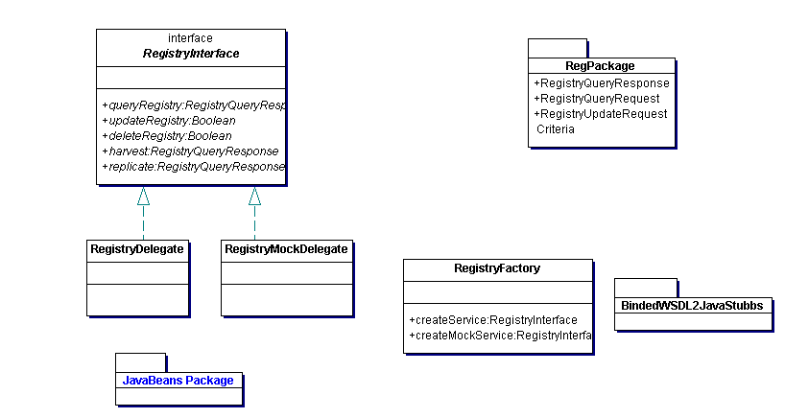

2.)Request and Response methods for the Web Service Interface
A VODescription is the top level (root) bean for the IVOASchema and under it has other javabean objects.

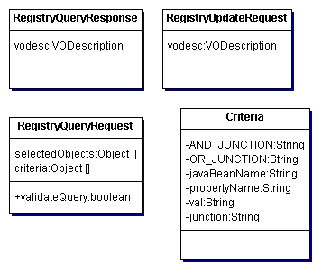

3.) Java Beans sample look. This was generated by Castor Source code Generator and not the XSL proposed in this design document. So please take this as an example look. Please also note that many of the abstract class types will disappear ex: ContactType, SourceType,CurrationType, and many more this was generated from Castor. Not real sure how to look at this picture unless you zoom to huge factor.

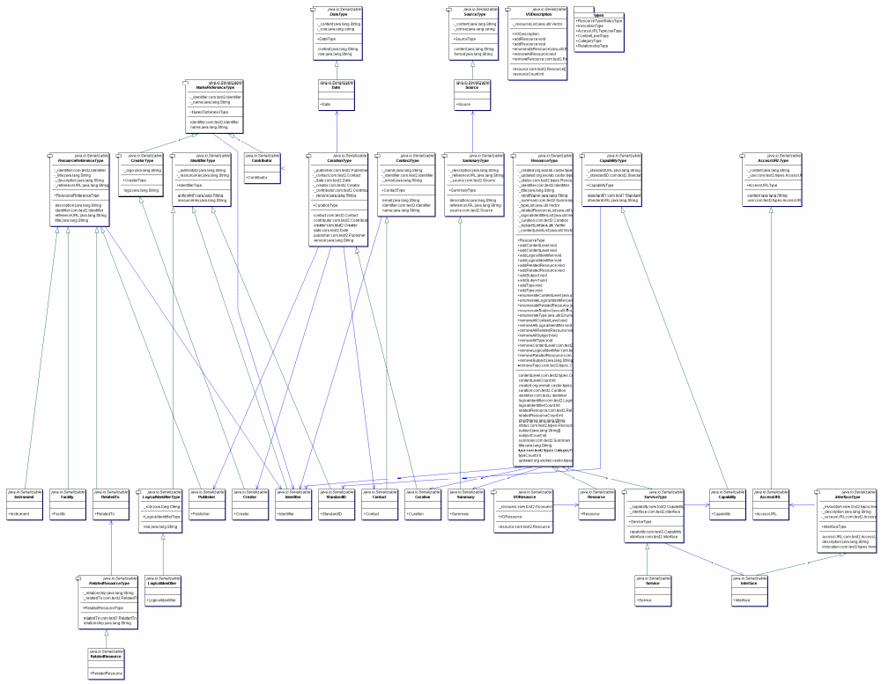

Appendix E – Astrogrid Java Beans
Mapping Schema to Beans prototype look for astrogrid.
All Beans below will have an internal “ident” integer column used.

ResourceBean

Ident, required, integer – used in astrogrid database internally
Identifier,required,IdentifierBean primary key
Title,required,xs:string
Summary, required,xs:string
ShortName, not required,xs:string
Type not required, Collection of strings possible vals = (“Other”, ”Archive”, ”Bibliography”, ”Catalog”, “Journal”, “Library”, “Simulation”, “Survey”, “Transformation”, “Education”, “Outreach”, “EPOResource”, “Animation”, “Artwork”, “Background”, “BasicData”, “Historical”, “Photographic”, “Press”, “Organisation”, “Project” “Person”)
RelatedResource, not required, Collection of RelatedResourceBeans
LogicalIdentifier, not required, Collection of IdentifierBeans with a role attribute of type xs:string
Curration, required,CurrationBean
Subject, not required, Collection of strings
ContentLevel, not required, Collection of Strings vals must be=(“General”, “Elementary Education”, “Middle School Education”, “Secondary Education”, “Community College”, “University”, “Research”, “Amateur”, “Informal Education”)
created, required, xs:date,THIS IS AN ATTRIBUTE
updated, required, xs:date, THIS IS AN ATTRIBUTE
status, required, string, default “active”, other values= “inactive”,”deleted”, THIS IS AN ATTRIBUTE

IdentifierBean
AuthorityID, required, xs:string
ResourceKey, required, nillable=”true”, xs:string

SummaryBean
Description,required,xs:string
ReferenceURL,required, xs:anyURI->xs:string
Source, not required,xs:string, has attribute of “format” type=”xs:string”

RelatedResourceBean
Relationship, required, xs:string (double check this later, comes from another schema), values are=(“mirror-of”,”service-for”,”derived-from”, “related-to”)
RelatedTo, required, ResourceReferenceBean

ResourceReferenceBean
IdentiferBean, not required
Title, required, xs:string
Description, not required, xs:string
ReferenceURL, not required, xs:anyURI->xs:string

CurrationBean
Publisher, required, ResourceReferenceBean
Contact, required,ContactBean
Date, not required,xs:string, with attribute called “role” type=xs:string with default=”representative”
Creator, required,CreatorBean
Contributor,not required,NameReferenceBean
Version, not required,xs:string

ContactBean
Name, required, xs:string
IdentifierBean, not required
Email, not required, xs:string

NameReferenceBean
IdentifierBean, not required
Name, required, xs:string

CreatorBean
?,NameReferenceBean, required
Logo, xs:anyURI->xs:string, not required

ServiceBean extends ResourceBean
Capability, not required,CapabilityBean
Interface, requitried,InterfaceBean

InterfaceBean
Invocation, required, xs:string, values required are = (“Custom”, “Extended”, “WebService, “WebBrowser”, “GLUService”)
Description, not required, xs:string
AccessURL, required, xs:anyURI->xs:string, with attribute use type=xs:string with values of = (“full”, “base”, “dir”)

CapabilityBean
StandardURL, not required, xs:anyURI->xs:string
StndardID, not required, IdentifierBean

VODataService.xsd
DataCollectionBean extends ResourceBean
Facility, not required, Collection of ResourceReferenceBean
Instrument, not required, Collection of ResourceReferenceBean
Coverage, not required, CoverageBean
Resolution, not required, xs:anyType ? -> xs:String or Object (Type not yet defined)
Access, not required, AccessBean

CoverageBean
Spatial, not required,xs:anyType ? -> xs:String or Object (Type not yet defined)
Spectral, not required, xs:anyType ? -> xs:String or Object (Type not yet defined)
Temporal, not required, xs:anyType ? -> xs:String or Object (Type not yet defined)

AccessBean
Format, not required, Collection of Strings (xs:string) with attribute isMIMEType type xs:Boolean default=false
Rights, not required, xs:string values are = (“public”, “secure”, “proprietary”,
AccessURL, not required, required, xs:anyURI->xs:string, with attribute use type=xs:string with values of = (“full”, “base”, “dir”)

SkyServiceBean extends ServiceBean
Facility, not required, Collection of ResourceReferenceBean
Instrument, not required, Collection of ResourceReferenceBean
Coverage, not required, CoverageBean
Resolution, not required, xs:anyType ? -> xs:String or Object (Type not yet defined)

ParamHTTP extends InterfaceBean (with Invocation set to “Extended”)
HTTPResults, required, xs:string
PARAM, not required, Collection (need to check this out it comes from Votable.xsd)
Qtype attribute type=xs:string values are = (“GET”,”POST”)

VORegistry.xsd
RegistryBean extends ServiceBean
ManagedAuthority, required, Collection of xs:strings

AuthorityBean extends ReosourceBean
ManagingOrg, not required, IdentifierBean
VOCommunity.xsd
OrganisationBean extends ResourceBean
Facility, not required, Collection of ResourceReferenceBean
Instrument, not required, Collection of ResourceReferenceBean

Project extends OrganisationBean

Appendix F – Extensions to the Beans
Okay this will need some reworking, but each Java Bean should have these methods and availabilities to them.

public Boolean validate() {

}

public Boolean equals() {

}

// Type metadata
private static org.apache.axis.description.TypeDesc typeDesc =
new org.apache.axis.description.TypeDesc(AddResponse.class);

static {
org.apache.axis.description.FieldDesc field = new org.apache.axis.description.ElementDesc();
field.setFieldName("addResult");
field.setXmlName(new javax.xml.namespace.QName("", "addResult"));
field.setXmlType(new javax.xml.namespace.QName("http://schemas.xmlsoap.org/soap/encoding/", "int"));
field.setMinOccursIs0(true);
typeDesc.addFieldDesc(field);
…//and keep adding your properties here.
};

/**
* Return type metadata object
*/
public static org.apache.axis.description.TypeDesc getTypeDesc() {
return typeDesc;
}

/**
* Get Custom Serializer
*/
public static org.apache.axis.encoding.Serializer getSerializer(
java.lang.String mechType,
java.lang.Class _javaType,
javax.xml.namespace.QName _xmlType) {
return
new org.apache.axis.encoding.ser.BeanSerializer(
_javaType, _xmlType, typeDesc);
}

/**
* Get Custom Deserializer
*/
public static org.apache.axis.encoding.Deserializer getDeserializer(
java.lang.String mechType,
java.lang.Class _javaType,
javax.xml.namespace.QName _xmlType) {
return
new org.apache.axis.encoding.ser.BeanDeserializer(
_javaType, _xmlType, typeDesc);
}

